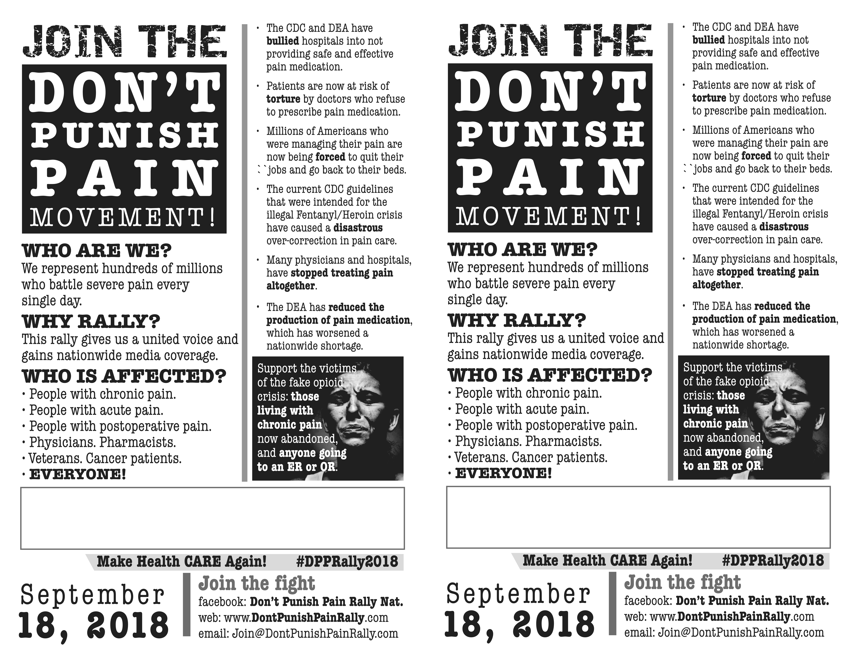
Anytown, Statename
Contact: City@DontPunishPainRally.com

Anytown, Statename
Contact: City@DontPunishPainRally.com

